PICTURES OF JOINT INVESTIGATION VISIT TO OANDO ENERGY RESOURCES LIMITED FACILITY AT 6” OGBOINBIRI/TEBIDABA PIPELINE, AT OGBOINBIRI/KEME-EBIAMA SILGA BAYELSA STATE ON 9TH OCTOBER, 2024.
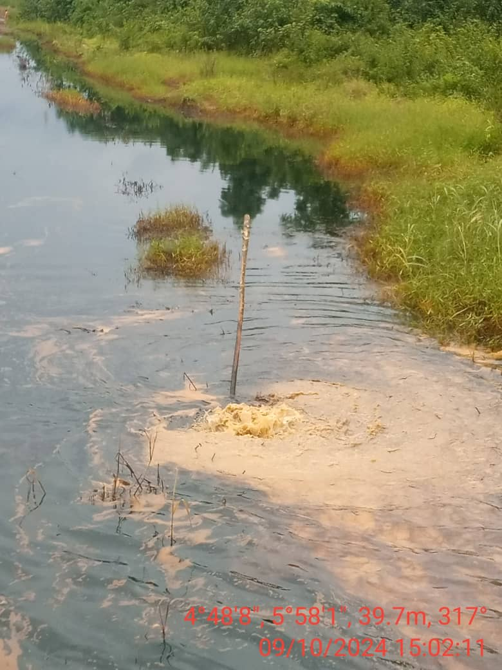
FIG. 1: STATE OF THE ENVIRONMENT AS AT THE TIME OF JIV.
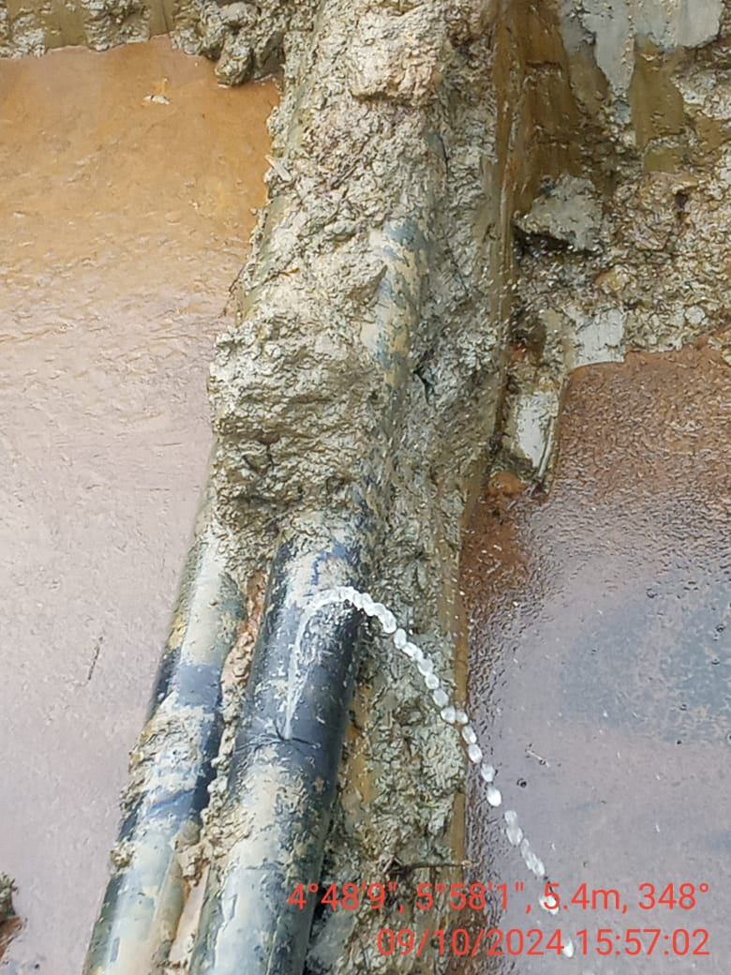
FIG. 2: ABOUT 100MM HACKSAW CUT EFFECTED AT 12 O’ CLOCK POSITION BY VANDAL(S).

